SRAM read operation

Shantonu Debnath

IIEST, Shibpur

**Netlist for read:**

**Author Shantonu Debnath

*source

vdd vdd 0 dc 1

*initial conditions stored for read operation

.ic v(Q)=0

.ic v(QR)=1

*data control

.ic v(bl)=1

.ic v(blb)=1

*access control

vwl wl 0 pwl(0 0 1ns 0 1.2ns 1 5ns 1)

*transistors used for latching

m1 QR Q 0 0 NMOS l=0.18u w=0.36u

m2 QR Q vdd vdd PMOS l=0.18u w=0.72u

m3 Q QR 0 0 NMOS l=0.18u w=0.36u

m4 Q QR vdd vdd PMOS l=0.18u w=0.72u

*transistors used for data access

m5 bl wl Q 0 NMOS l=0.18u w=0.36u

m6 blb wl QR 0 NMOS l=0.18u w=0.36u

.tran 1n 5n

.probe

.MODEL NMOS NMOS

+ LEVEL = 3

+ VTO = 0.41

+ TOX = 2.2E-09

+ NSUB = 2.0E+18

+ NFS = 6.0E+12

+ XJ = 6E-8

+ LD = 9e-9

+ UO = 390

+ VMAX = 2.2E+05

+ THETA = 0.80

+ ETA = 2.8E-03

+ KAPPA = 0.2

+ GAMMA = 0.40

+ RSH = 500

+ CGSO = 3.33449e-10

+ CGDO = 3.33449e-10

+ CGBO = 0.0

+ CJ = 4.96491e-3

+ CJSW = 2.45744e-10

.MODEL PMOS PMOS

+ LEVEL = 3

+ VTO = -0.41

+ TOX = 2.2E-09

+ NSUB = 2.0E+18

+ NFS = 6.0E+12

+ XJ = 6E-8

+ LD = 9e-9

+ UO = 175

+ VMAX = 1.1E+05

+ THETA = 0.80

+ ETA = 2.8E-03

+ KAPPA = 0.2

+ GAMMA = 0.40

+ RSH = 500

+ CGSO = 3.33449e-10

+ CGDO = 3.33449e-10

+ CGBO = 0.0

+ CJ = 4.96491e-3

+ CJSW = 2.45744e-10

*.model NMOS NMOS [kp=20u vto=0 lambda=0]

*.model PMOS PMOS [kp=20u vto=0 lambda=0]

.options POST=2

.options AUTOSTOP

.options INGOLD=2 DCON=1

.options GSHUNT=1e-12 RMIN=1e-15

.options ABSTOL=1e-5 ABSVDC=1e-4

.options RELTOL=1e-2 RELVDC=1e-2

.options NUMDGT=4 PIVOT=13

.options runlvl=6

.end

**Result:**

When bit low read 0

And when bit bar low read 1

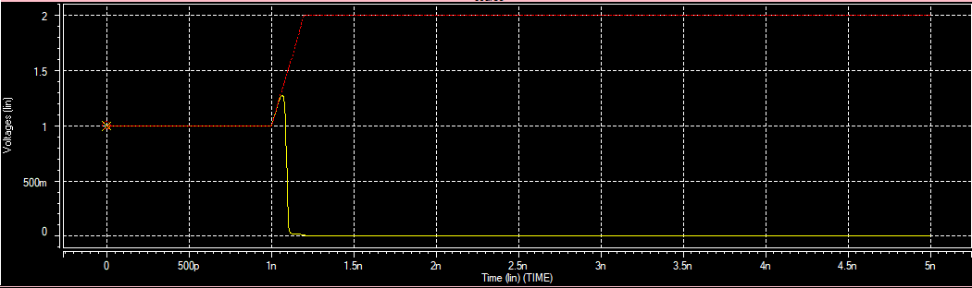

Read 0 Red: Bit Yellow: Bit bar